

**LAB MANUAL**

**Course: CSC412 – Visual Progra**

**mming**



**Department of Computer Science**

**Learning Procedure**

1. Stage **J** (**Journey inside-out the concept**)
2. Stage **a1** (**Apply the learned**)
3. Stage **v** (**Verify the accuracy**)
4. Stage **a2** (**Assess your work**)

**COMSATS Institute of Information Technology (CIIT)**

i

**Islamabad**

**LAB # 09**

# Statement Purpose:

This lab will give you an introduction on how to create and use Dynamic Link Libraries using C# language.

# Activity Outcomes:

This lab teaches you the following topics:

* + Understanding Dynamic Link Libraries.
  + Creating a Dynamic Link Library(dll)
  + Using dll in another application
  + Understanding difference of static and dynamic libraries.

# Instructor Note:

Download and Install Visual Studio 2015 or above. In this lab, Visual Studio 201 is used.

# Stage J (Journey) Introduction

**DLL** file contains compiled code you can use in your application to perform specific program functions and may be required by another application or module (such as . exe or . **dll**) to load it through an entry point. It is a library that contains code and data that can be used by more than one program at the same time.

It can be used in other Console applications, windows applications, dlls, web applications and many more by adding reference. Dynamic Link Libraries (DLL)s are like EXEs but they are not directly executable. They are similar to .so files in Linux/Unix. That is to say, DLLs are MS's implementation of shared libraries. DLLs are so much like an EXE that the file format itself is the same. Both EXE and DLLs are based on the Portable Executable (PE) file format. DLLs can also contain COM components and .NET libraries.

# Stage a1 (apply) Lab Activities:

### Activity 1:

Create a DLL using Visual Studio environment.

### Solution:

Follow these steps for creating a dll :

* Open Visual Studio then select "File" -> "New" -> "Project..." then seelct "Visual C#"  -> "Class library“.
* In the class of namespace, write methods for the different functionality.
* Build the solution (F6). If the build is successful then you will see a “ProjName.dll" file in the "bin/debug" directory of your project.

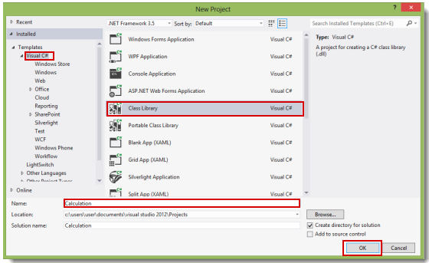

### Activity 2:

Create a DLL **Calculation**. It should contain functions in the class of namespace for Addition, Subtraction, Multiplication and Division. All these functions should return a result value after performing these functionalities.

int Add(int,int);

int Subtract(int,int);

int Multiply(int,int);

int Divide(int,int);

Multiply()

### Activity 3:

Create a windows Forms Application **Calculator**. This application should use the dll created in Activity2 for performing different operations.

For adding reference follow these steps:

* Add a reference for the dll file, "calculation.dll", that we created earlier. Right-click

on the project and then click on "Add reference".

* Select the DLL file and add it to the project.
* After adding the file, you will see that the dll namespace has been added (in references)
* Also add reference on top of the application where other dlls are added

### Static methods can be used directly with class name. For non static methods create an object of

### the class of the dll and use methods with the object.

# Stage v (verify) Home Activities:

### Activity :

Develop a Windows based Scientific Calculator. All the functions are required to be in the DLL. Calculator application will perform all functionalities using this dll.